Task# Description | Task ID: | Todo | Test Results: |  |  | 3
Task# Description | Requirement: |  | User: |  |  | 3
Task# Description | Test Case: |  | QA Administrator: |  |  | of
Task# Description | Script Version: | 1 | Defect # : |  |  | of
Task# Description | Script Author: | Jodee Bell | Target Test Date: |  |  | 1
Task# Description | Project Leader: |  | Actual Test Date: |  |  | 1
Task# Description | Description: |  |  |  |  | Page
Task# Description | Setup Requirements: | Go through pre-req for using the Todo tool, install any needed perquisite then open fooling URL  http://todomvc.com/examples/angular2/
Step Nbr | Process Description |  | Expected Results |  | Actual Results | Pass
1 | Copy and paste the following URL into chrome  http://todomvc.com/examples/angular2/ |  | Todos will launch and allow you to enter in new Tasks
2 | Copy and paste the following URL into internet explorer  http://todomvc.com/examples/angular2/ |  | Todos will launch and allow you to enter in new Tasks
3 | Open the following http://todomvc.com/examples/angular2/  In the What needs to be done field, enter a new task  Called tests cases, hit enter |  | Once enter is hit the task you entered should show below and have a circle next to it allowing you to enter a new task
4 | In the What needs to be done field enter a new task called Automation, hit enter |  | Once enter is hit the task should fall below the first task you created, and have a circle by it.
5 | Double click on the test case task and edit the name to 6 test cases |  | The line your double clicking should allow you to edit the task name
6 | Click the circle next to the task named Automation |  | A Check box should appear and at the bottom of the page it will say clear complete 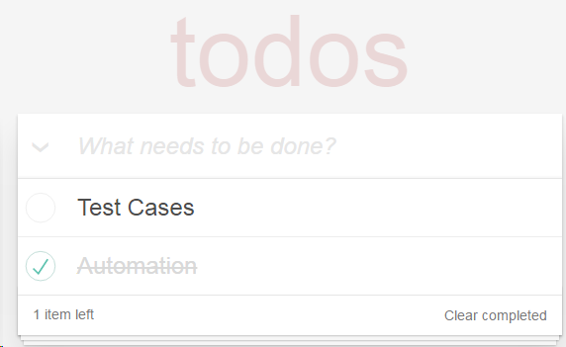
7 | Hover the mouse on the right side of the task |  | An x should appear 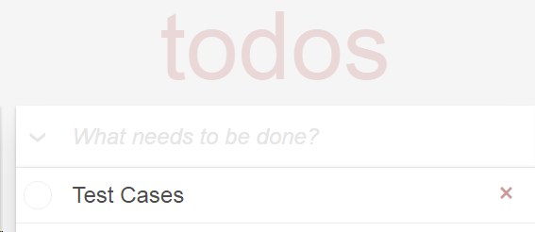
8 | In the What needs to be done field click on the pulldown arrow. |  | All the circles should fill with check marks and there should be a clear
9
10
11
12
13
14

Test Script Template Form Entry Definition Table
Field | Form Entry | Description
R | Script Name | Identifiable name to be given to the Test Script
R | Task ID | Task # assigned by ACCESS
R | Requirement # | The assigned Requirement #
R | Test Case # | The assigned Test Case # to satisfy the Requirement #
R | Script Version | Version Test Script starting with V1 (versioning is used to track changes)
R | Script Author | The person responsible for creating and publishing the script
R | Project Leader | The person assigned to manage the Task
R | Test Results | Pass or Fail
RC | User | Designated person assigned to do User Acceptance Testing
RC | QA Administrator | Designated person assigned to do Integrated System Testing
RC | Defect # | The Number assigned to a defect found while testing
R | Target Test Date | Target Test Start Date
R | Actual Test Date | Actual date(s) testing occurred
R | Description | A brief description of the Test Script
RC | Setup Requirements | State special setup processes or procedures that are required in order to perform the test
R | Step Nbr. | Numerated step within the Test Script
R | Process Description | Describe what needs to be done to execute the step
R | Expected Results | Describe what results should be expected after executing the step
R | Actual Results | Document what were the results after executing the step
R | Pass | Y = Passed N = Failed
Field Definition
R = Required
RC = Required Conditional

